Artificial Intelligence: Exercise sheet 1

# Solution by: Yu Xiang, Matrikei. Nr: 3529787, Email: shawnxiangyu@yahoo.com

# Python version 3.6

## Introduction to Python – Chatbot

### Conversation 1

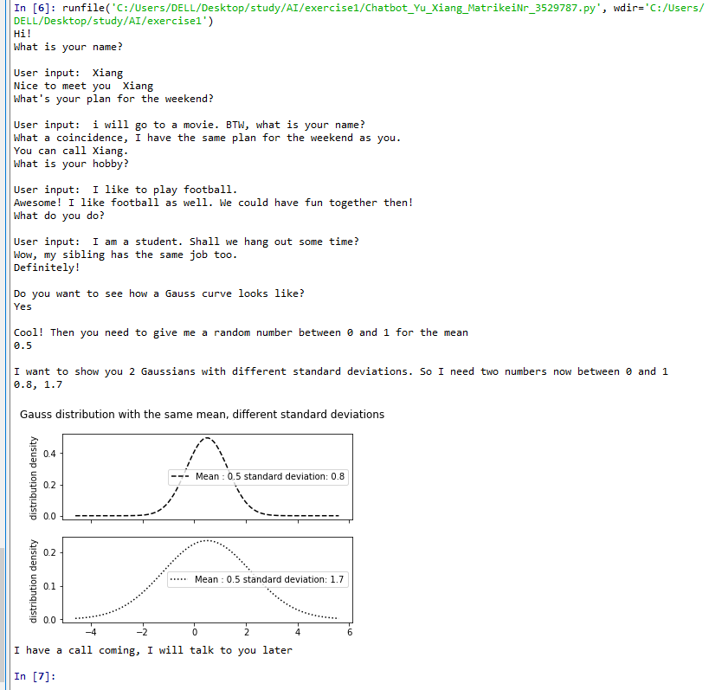

### Conversation 2:

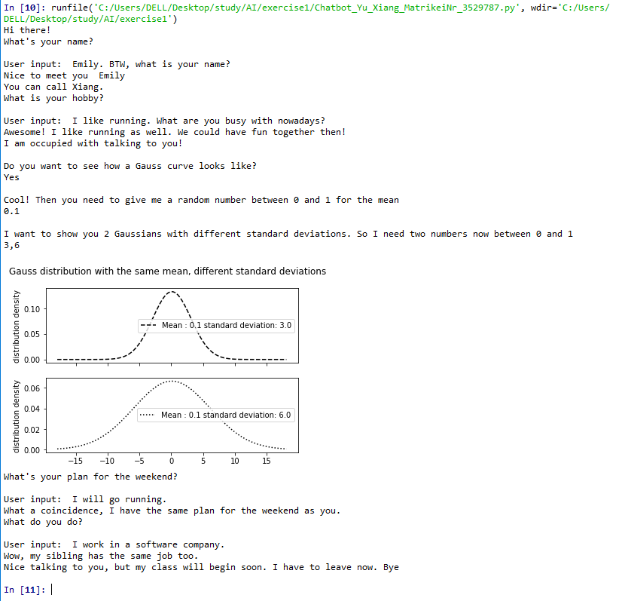

## Agents – chatbot

### a). PEAS description

* Performance measure: time and sematic correctness.   
  Here time could refer to the maximum time that the user cannot tell whether the chat is from a human being or a machine; sematic correctness means that the answer and questions from the machine is similar to that from human being.
* Environment: Computers, rooms, staff
* Actuators: screen display
* Sensors: keyboard

b). The environment is fully observable, deterministic, sequential (not episodic), static, discrete and single – agent.

* Fully observable: The sensor (keyboard) gives the chatbot the complete state of the environment at each point in time.
* Deterministic: The next state (talk, questions and answer) of the environment is completely determined by the current state (current question and answer) and the action (the chat) executed by the agent (chatbot).
* Sequential: The last step of the chat has influence on current chat. The choice of action in each episode depends on previous episode.
* Static: The environment is unchanged.
* Discrete: There are only a limited number of distinct, clearly defined percepts and action. The chatbot can give meaningful answers to a limit number of questions.
* Single Agent: The chatbot is operated by itself in an environment.

c). Yes: e.g. Google Allo and Zopim

* The Google Allo purpose is to provide accurate answer to the user questions, it could also learn from the conversation and feedback from the user and improve the correctness. It could also do some casual talks with the user. This is a learning agent.
* Zopim is a chatbot for customer service. Zopim’s purpose is to help to user to find the answer to the questions more quickly. The questions are pre-defined and stored, it will be able to find the relevant answers based on the keyword, however, it could not find answer to questions who are not in the database. This agent could also suggest some possible solutions if the exact answer is not found. This is a model-based reflex agent.

d). Our chatbot is a simple reflex agent. Because it follows very simple rule. Based on this rule, if the current condition matches, then the agent does the right thing associated with that rule.